H.O.P.E. For All’s Impact
On Anne Arundel County
July 2014 – June 2015

We ensure that adults and children who are transitioning out of homelessness can be realistically prepared to begin their new lives with caring support from their community.

Households served: 208 (700 individuals)
Clothing only: Additional 2,000 – 3,000 individuals
Goods Provided
Clothing: 28,093 items
Furniture: 2,141 items
Household: 5,400 items
Linens: 5,311 items
Cleaning/Toiletries: 102 Baskets
Diapers/Wipes: 5,847 items
School Supplies: 321 items
Toys/Books: 74 items

Total Value of Goods Provided: $487,875

H.O.P.E. For All’s Impact on Anne Arundel County
July 2014 - June 2015
Page 2
Employs: 1 Full Time, 2 Part Time
Wages and Taxes: $57,864
Business Expenses: $8,504

Rents 4 Warehouses (8,700 sq ft)
Rent: $41,361
Utilities: $4,845

Operates 2 Vans and 1 Trailer
Vehicle Expenses: $4,150
Insurance: $11,324

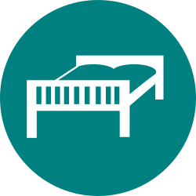
Purchases Furniture, Housewares & Clothing NOT Donated
Inventory Purchases: $15,094

Value of Goods: $487,875
Operational Costs: $143,242
Total Investment in the Community: $631,117

H.O.P.E. For All’s Impact on Anne Arundel County
July 2014 - June 2015
Page 3
Volunteer Hours: 3,098
An additional $55,764 value to the community

Anne Arundel County Grant: $5,000
Covers only 3.5% of Operational Costs

In Anne Arundel County
We are the Missing Link to Self Sufficiency

